Who needs a Police Check?
Basically, everyone who performs a role within the church or an Op shop.
All Clergy, PTOs, Admin staff, Parish Council members, Synod Reps, Church workers, Op Shop volunteers, and even garden maintenance people need a police clearance.
The Safe Church police check is different to the Working with Children police check. The Working with Children police check covers offences of rape, sexual assault & violence and pornography. The Police check covers other offences such as fraud, murder, drugs,etc.
Please refer to the Diocesan Safe Church Compliance Process for full listing of roles.
NOTE: If you have a recent Police clearance certificate from another organisation, a copy of that would be acceptable to submit in lieu of this process. It needs to be less than 12 mths old.

The Process – Using Crimcheck (no cost to the applicant)
Step One:
Access the Crimcheck Application on the Diocesan Website via this link: https://www.crimcheck.org.au/check/ADG
OR follow the links through the website: Anglican Diocese of Gippsland / Resources / Safe Ministry / Crimcheck Online Application
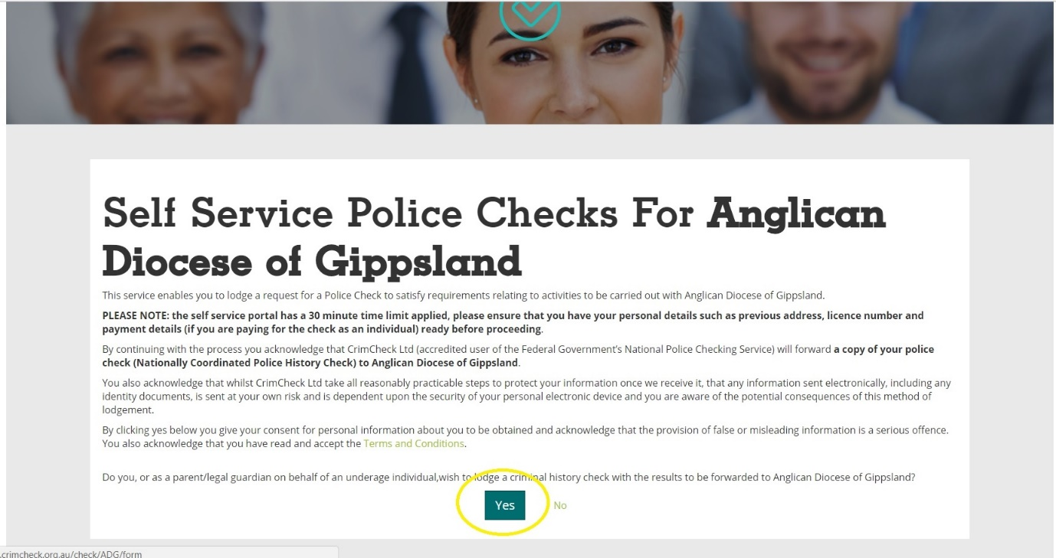
Go to https://www.crimcheck.org.au/check/ADG and select the option ‘Yes’

Step Two:
Select Employee(Paid) or Volunteer as appropriate. NOTE: Most people will be under the Volunteer category unless they are paid for the role as an employee of the Diocese.
For example, once you select Volunteer, the system confirms the check is a Probity Check.
Next enter:
Position title/role: for example – Church Worker, Lay Reader, Youth Leader, Op Shop volunteer, etc.
Employer/Organisation: Anglican Diocese of Gippsland
Location: Parish name or Op shop location
State: VIC
When these have been entered select ‘Submit.’
Step Three:
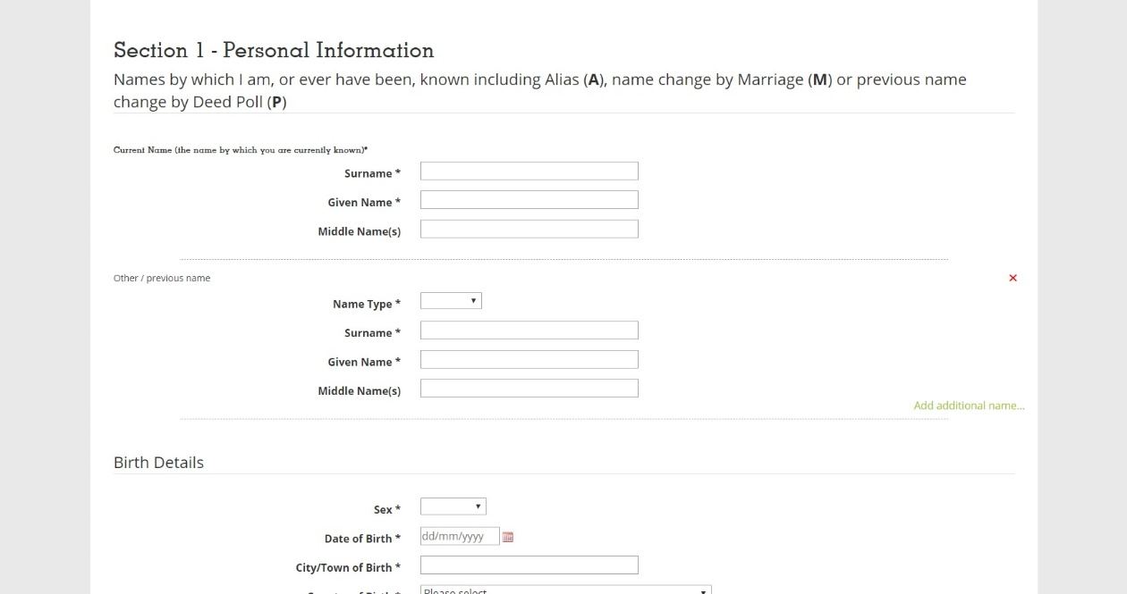
Proceed to fill in all your personal information as indicated on the page and select “Submit” when finished.

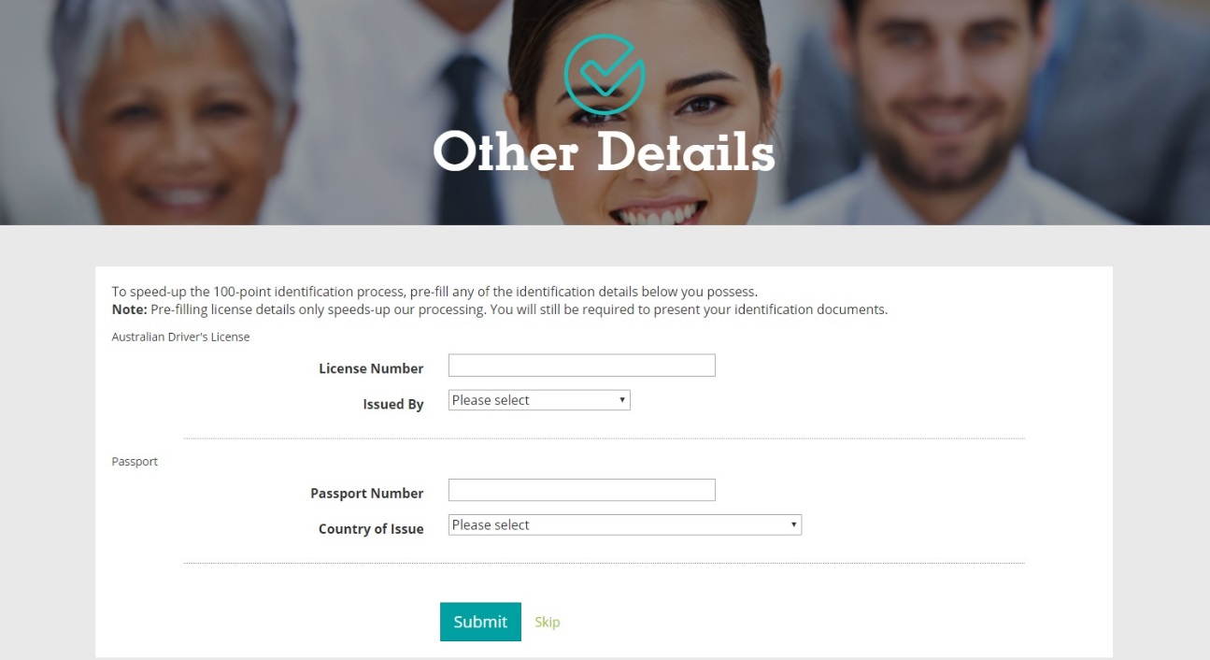
Step Four: Enter in your details if you have a Driver’s License and/or current Passport (more ID options will be explained in Step Five) and select “Submit”

Step Five:
Your Police Check application has now been entered into the system. However, before it can be processed, the Diocese needs copies of your ID to complete the verification section of the police clearance application.
The police clearance system, used by the Diocese, requires four forms of ID. They are split into different categories.
NOTE: With all these documents, we only require a legible copy.It is no longer necessary for these copies to be certified.

One “commencement of identity” document as listed below:

One “primary use in the community” document as listed below:

Two “secondary use in the community” documents as listed below:
Secondary use in the community documents
(a) certificate of identity issued by DFAT to refugees & non-Australian citizens for entry to Australia
(b) document of identity issued by DFAT to Australian citizens or persons who have the nationality of a Commonwealth country for travel purposes
(c) convention travel document secondary (United Nations) issued by DFAT
(d) foreign government issued documents (for example, drivers’ licence)
(e) Medicare card
(f) enrolment with the Australian Electoral Commission
(g) security guard or crowd control photo licence
(h) evidence of right to an Australian Government benefit (Centrelink or Veterans’ Affairs)
(i) consular photo identity card issued by DFAT
(j) photo identity card issued to an officer by a police force
(k) photo identity card issued by the Australian Defence Force
(l) photo identity card issued by the Australian Government or a state or territory government (this may take the form of a Working with Children/Vulnerable People Card or a government occupational licence);
(m) Aviation Security Identification Card (ASIC)
(n) Maritime Security Identification Card (MSIC)
(o) Firearms licence
(p) credit reference check
(q) Australian secondary or tertiary student photo identity document
(r) Certified academic transcript from Australian university or registered higher education provider.
(s) trusted referees report
(t) bank card, credit card or bank statement (without recording the payment/card number/s)
(u) Australian tax file number
(v) State/territory government rates assessment notice or Australian Taxation
Office assessment notice; Must not be issued more than 12 Months prior to use.
(w) Australian utility bill showing name and address.
(x) Australian private health insurance card.
(y) Australian trade association card

Once you have copies of these, please scan and send them via email to clearances@gippsanglican.org.au OR
securely post to: PO Box 928, Sale, VIC, 3850 Attn: Clearances.
Your identity documents must be verified by Clearance officer before the Police check can be processed and are treated as highly confidential.
NOTE: No copies of identity documents are kept once police check has been certified – as required by law.
After these IDs have been received at the Diocese office - your Police Check will be processed.
Should you have any queries regarding the process or what is required, you can contact the Clearance officer at Diocese office on 5144 2044
or send an email to clearances@gippsanglican.org.au

