**Gippsland Anglicans**

**Year of the Gutter**

**Before undertaking gutter cleaning task**

1. **Fill fuel tank on generator and fuel jerry can**
2. **Charge batteries on camera and monitor, for at least 5-6 hours (Recommended overnight)**
3. **Fill water container with approx. 1 litre water**

**For serious stuff-ups or general advice please call**

**Richard Connelly on 0422 109 629**

**5kva Generator User Guide**

* There is no need to adjust the throttle setting *

1. Fill fuel tank with unleaded petrol, or ethanol-added petrol (E10)

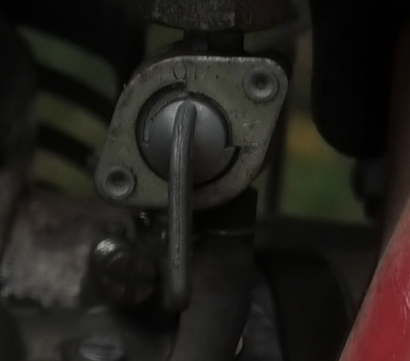

**Fuel Switch**

1. Turn fuel tap to “On”
2. Press motor switch to “On”
3. Pull choke button out when motor ‘cold’ or for first start of the day

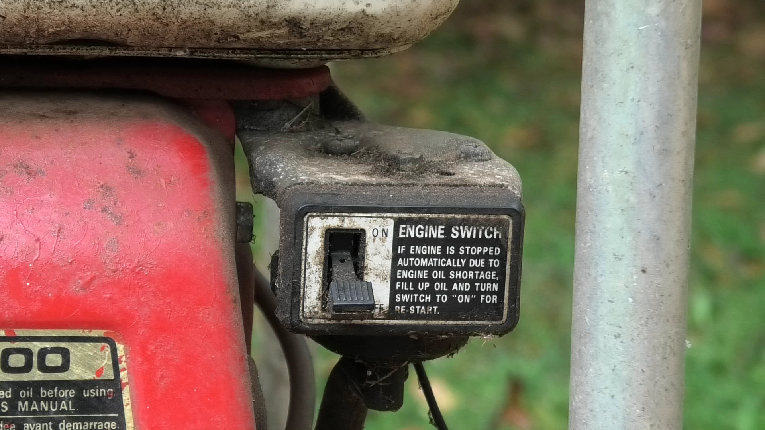

**On /Off Switch**

1. Vigorously pull start cord. The motor usually starts on its second pull.

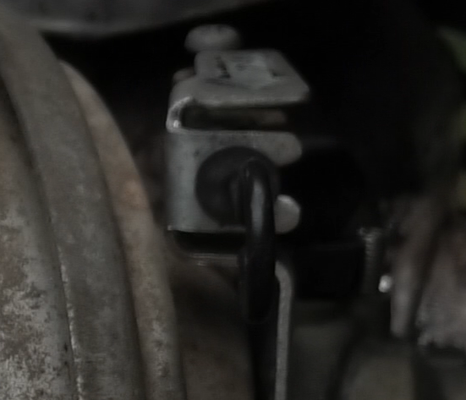

**Choke**

1. Once running, push in the choke button
2. Turn motor switch to “Off” to shut down motor
3. Turn fuel tap to “Off”

**Generator - Background Info**

* The vacuum unit can draw up to 12.3 Amps
* Many ageing or small church power systems only provide 10 Amps of current
* There may be a strong likelihood of blowing fuses or trip switches and a lesser risk of further damage to electrical systems and / or fire
* **Users are encouraged to use the supplied 5KVA generator** to ensure power supply to church building is not compromised, unless advice is received that power supply of property is sufficient.

**Use of High Flow setting**

Use for significant blockage in gutter, for example matted debris or clumps of growing weeds /grass

Only use for 2-3 minutes as it places significant strain on motor unit and may lead to overheating / burn-out of motors.

If successful in removing clumps of material, drop to ground by opening air-lock release on bottom pipe.

**SkyVac Assembly Guide**

**Vacuum Unit**

1. Connect extension cord to generator and vacuum unit.

**Video A**

1. Check vacuum drum is empty prior to use
2. Check filter on base of motor head unit is not visibly

encrusted or clogged with dirt, debris or mud. If so, rinse

under tap, preferably wash from inside of filter cylinder

outwards with a hose

1. Refit vacuum motor head to drum, ensuring switches are

facing towards handle on drum frame.

1. Connect flexible vacuum tube to SkyVac unit, which clips in

by pushing

**Pole assembly**

Assemble black carbon-fibre poles in the following order:

**Video B**  **Video B**

* 1. Pole with airlock (marked with white cable tie) on

bottom

* 1. Varying number of extension poles as required (e.g

+1 for single story, +5 for gutters at Cathedral)

* 1. Gooseneck fitting goes next, on top of black poles
  2. Aluminium extension pole (marked with red paint), to

Reach into gutters.

1. Join vacuum tube to pole assembly

**Camera/Monitor**

**Video C**

1. Fit camera to head of pole assembly (on gooseneck fitting)
2. Turn camera and monitor on
3. Check alignment of camera with viewing monitor
4. Fit viewing monitor on base of pole at convenient height

for user.

**Operation**

1. Turn generator on. Turn on motors on vacuum: White switch

**Video D**

in middle first, and then two red switches

1. Proceed to clean gutters
2. Check drum unit occasionally (say every hour) to check

rate of filling up. If the unit seems to lose power the drum

may be full.

**Use of High Flow setting (See Insert)**

1. At completion of job: Flush hose and pipes with water from

supplied bucket

1. Turn off vacuum and generator
2. Empty Drum
3. Pack up unit

**User Tips & Tricks**

* Keep an eye on the vacuum hose to make sure it doesn’t kink and become blocked.
* Whilst users have access to a screen to monitor the leaf debris in the gutter, with experience it is often easier to operate the unit by ‘feel’ and not by sight. Sliding the head of the poles ‘backwards’ towards the user lets a user feel debris inside the gutter. The vacuum motor changes pitch as it sucks up material and a vibration can be felt through the poles. Wet material being sucked up often makes the poles colder to touch. **An alternative to using the camera is to use the supplied mirror attached to a pole to view the amount and location of debris prior to starting.** Try different methods and find which way works best for you.
* Blockages at the head of the pipe can be dislodged by sliding the pipe outlet against the roof/gutter, or by opening the air-lock release on the bottom pipe. Once the vacuum is released, a blockage may drop down due to gravity. Occasionally the head has to be lowered to be manually unblocked.

**Problem solving guide**

|  |  |  |
| --- | --- | --- |
| **Problem** | **Probable Cause** | **Remedy** |
| Poor suction | Blocked filter or full bin | Clean filter and empty bin |
| Poor suction | Blockages in gooseneck or poles or vac entrance | Clear blockages |
| Poor suction | Leaves blocking at end tool | Tap leaves and end tool on roof/tiles |
| Poor suction | Damp debris builds up inside vacuum hose or tubes | Suck water from bucket to clean pipe/poles |
| Suction not powerful enough |  | Ensure all 3 motor switches are on |
| Camera screen frozen | Lock out | 1. Turn monitor off and on again 2. Select reset button on back of monitor |
| Machine stopped working | Over-heated | Clean filter and leave machine for 10 mins to cool down.  Ensure power mix lever is to the left |
| Machine stopped working | Power supply | Always use heavy duty extension leads (20 Amp) |