**Solar Panels for The Abbey?**

**Care for creation?**

**Yes!**

**Together we can make a difference!**

At its recent meeting The Abbey Chapter endorsed the use of solar energy as integral to the development and mission of The Abbey as a Centre for Spirituality and the Environment.

The use of solar energy - renewable energy - is just the responsible way to live bearing in mind God’s call to Christians to care for and tend God’s creation.   It’s also a smart way to live as solar energy will be cheaper now and we will save money more and more into the future.

The Abbey Chapter is proposing to put solar panels on the Administration Building as well as West Cottage. These panels together will service the Administration Building, the A Frame, Illawarra and The Chapel as well as West Cottage and The Units, with back up from the grid.

The cost to install solar panels will be $15,000.

Anglican Earthcare Gippsland Inc is supporting The Abbey to make the transition to solar energy as an important component of its ministry and responsibility to care for the environment and invites your support.

**How to make your contribution**

Anglican Earthcare Gippsland Inc (AEG) Public Gift Fund has set up a ‘Solar for The Abbey’ Fund and invites your contribution – however large or small!

**All donations over $2 to the Public Gift Fund of Anglican Earthcare Gippsland Inc are tax deductible.**

To make your donation

By Cheque to:                Anglican Earthcare Gippsland, Solar for The Abbey

Mail to:                         The Abbey, PO Box 77, Paynesville 3880

                                         Please include your name and address for a tax receipt

Direct Deposit:              Anglican Earthcare Gippsland

                                        ANZ Bank, BSB 013795, Acct # 2060 78399

                                        Please use surname and SA as reference

For Tax Receipt:          Email [info@theabbey.org.au](mailto:info@theabbey.org.au) to confirm your donation and to request a tax receipt.

***Kind regards***

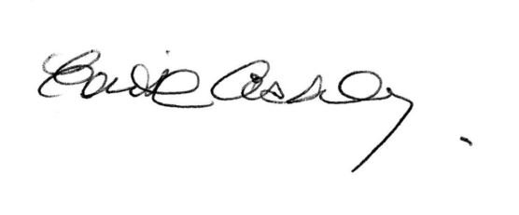

***Edie Ashley***

***Abbey Priest***

***The Abbey Conference and Accommodation Centre***

***Phone: (03) 5156 6580***

[**www.theabbey.org.au**](http://www.theabbey.org.au/)

[Find us on Facebook](http://www.facebook.com/gippslandhighcountrytours)

